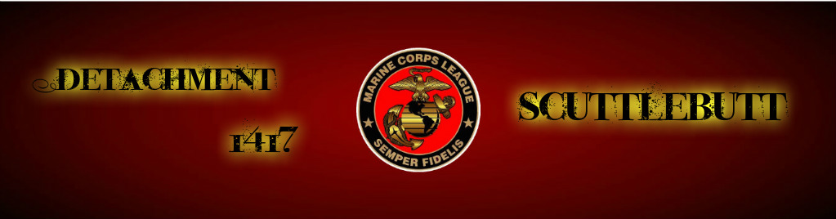
October 2016 Year 1, Edition 10
Commandant’s Corner
Marines and Associates, I first want to let you all know that I am on the mend from my back surgery. The surgeons got the piece of disc that was causing the nerve issues in my back and leg and I am recovering and looking forward to being my old active self very soon.
As you all know our Marine Ball is fast approaching and I want to see all of you there to help celebrate 241 years of Marine Corps excellence. We are called "the few, the proud" for a reason. It will be a fantastic event and even more special because we are having the ball on the actual birthdate of our beloved Corps.
Coming up on December 3rd we will be participating in the Weaverville Christmas Parade and I will need to get everyone interested in participating to get in touch with me and start getting things put together to do a float or whatever we can do to represent out Detachment.
Thank you all for everything you do for this detachment!

SEMPER FI
Commandant Ledford

Next Meeting: October 25, 2016

Detachment 1417 Board:

Commandant Ric Ledford

Sr Vice Bob Scar

Jr Vice Don Chatham

Judge Advocate Jack Albright

Past Commandant Larry Thornton

Chaplain Gene Ray

Paymaster Anthony Guidone

Sergeant-at-Arms Phil Swartz

Adjutant/Newsletter/Webmaster Phaedra Laushance

Detachment Email:
mcl.asheville@gmail.com

DATES FROM NC MCL QUARTERLY
Winter Quarterly:
6-7 January 2017, Salisbury, NC

Spring Quarterly:
9-10 March 2017, Asheville, NC

State Convention:
2-3 June, Raleigh, NC

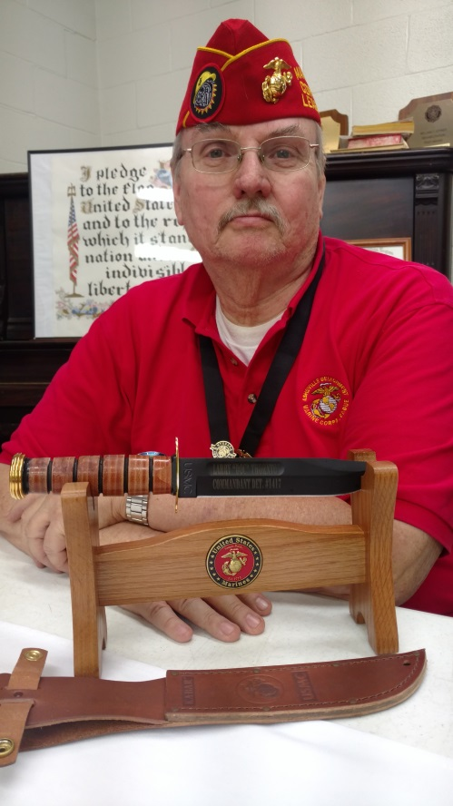
PJC Larry Thornton proudly displays his KA-BAR given to him by the Detachment for his years of service as our founding Commandant. Thank you PJC Thornton!

Monthly Dinners:
(All dinners begin at 1800 (6pm)

November 10th: Birthday Ball, Asheville Event Center

December 6th: Christmas Party, O’Charley's
(Don’t forget to get a gift of $10 or less for the White Elephant gift exchange. This is not necessary, but it is for fun!)

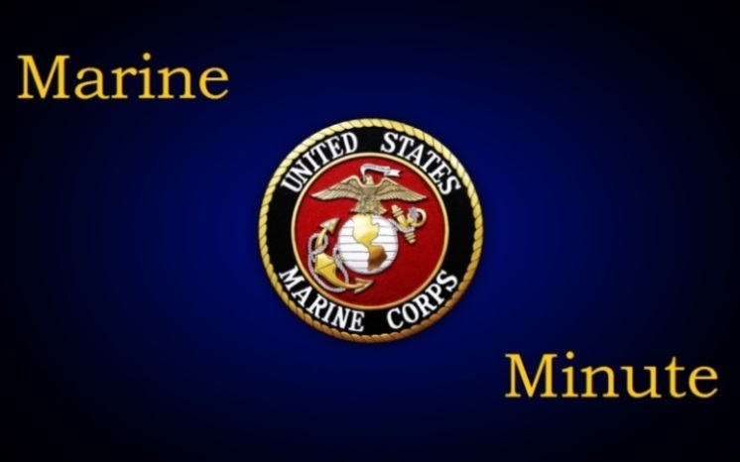

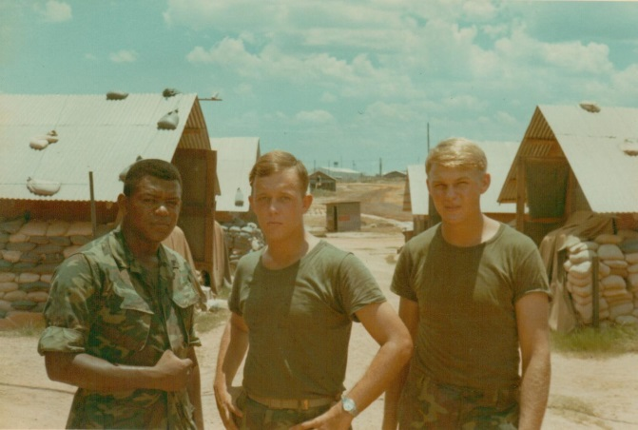
(John Powers, center)

Sgt. John A. Powers 2354332
Six years of service 1967-1973
Ground Radio Repairman/Radio Operator
My favorite duty station was MCRD San Diego
After leaving the Marine Corps I was employed in the floor covering business before I became a full-time pastor in early 1980's.
I am married to my wife of forty-six years, Peggy Moody Powers. We have actually been together since we were thirteen years old. We were blessed with one daughter, Pamela Labreeska Powers Moss who has given
us four grandchildren, Caleb, Joshua, Maddie Susan and Elijah. They are the light of my life and were instrumental in my recovery from four open heart surgeries including a heart transplant on Christmas day, 2014.
The newest addition to my family is my new dog, Kipper. He
is a Maltese/Yorkie mix and I am convinced is a member of the VietCong who has come back to terrorize me. Just kidding. Peggy and I would be lost without him.
My hobbies are reading (history, biblical and mystery/intrigue), and golf. I once played to a three handicap but I would be stretching it to say that I was even an eighteen now. A five-year layoff and four major surgeries have wreaked havoc with my game, but I enjoy it as much as ever.
I served in Vietnam with the Third Combat Engineer Battalion during 1969 and 1970. I was assigned as a 2841, Field Radio Repairman when I arrived in country, but was informed by my First Sergeant that we did not repair radios, we broke them. From that point on I became a field
radio operator. We spent most of our time clearing roads, destroying tunnels and weapons caches and clearing LZ's. It was during this time that I was exposed to heavy concentrations of Agent Orange which led to my early onset heart disease. I had my first heart attack when I was thirty-seven, and my first open heart surgery when I was
thirty-eight.
I am a deeply committed Christian who loves my God, my
family and my Beloved Marine Corps more than anything. Semper Fi!

∞∞∞∞∞∞∞∞∞∞∞∞∞∞∞∞∞∞∞∞∞∞∞∞∞∞∞

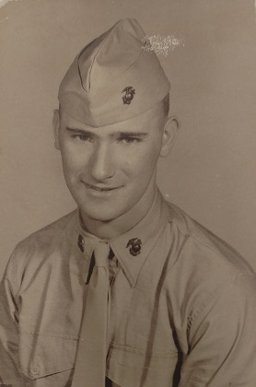

S/SGT Donald L. Chatham 1881903
Enlistment 12/01/1959-12/01/2001 Discharge
Basic Training: Parris Island, SC
Other Military Training (Include Schooling): National Match Mat. Course. Rock Island Ars Apps, Defence Mapping School, GPS Defense Mapping School, Combat Eng, School FT Belvor, AISI Sury, INST School Austin, TX, DeMO FT Belyoir, Small Arms Repair.

Bases & Locations served at in USA: PI,
Camp Giger, Camp Pendelton, Quantico, VA,
FT A.P. Hill VA, FT Belyoir VA, Rock Island Arsneg, IL, FT Benning, FT Lewis, WA, Yakama Firing Center, WA, FT Mead, MA

Bases Outside USA: K. Bay, HI, Okinawa, JP, Subic Bay, Phili, Yokosa, JP, Honduras, Hohenfels, Germany.
MC & Other Units You Served with: BN 2/4, BN 3/ 4, 1st Marine Bres. HQ CO, HQ BN Quantico, VA, (Army) D.C. 458, ENG BW (Combat) 343ASA Co. D Co. 429 Heavy ENG Co, 319 ENG Co, DE L, 343 ENG Co, HQ 99 ARCOM, 335TH PAA BN., DET 1 302 ENG Co., HHC 458, TA ENG BN.

List of Medals & Awards Received: Good Conduct Marine Corps; National Defense with BSTR; Overseas Ribbon; ASR; ARMY Res OTC; ARMY AAM; NCO, PROF, DEV RBN – 2; ARCAM 182,3,4; AFRAM 1, 2; ARCOTR; PISTOL EXP; RIFLE EXP; MACHINE GUN EXP; GLOBAL WAR ON TERROR SERV; ARMED FORCES SERV; ARMED FORCES EXP.

Other Military Organizations to which you belong (ie VFW, etc): 2nd BN 4th Marine Assoc, 3rd BN 4th Marine Assoc, Marine Corps Association.
(Any mistakes in this printing, see Don Chatham)

In our newsletters we are now making it a point to showcase the Marines of our detachment. You are just as important as all the others. So, please take a moment to provide us with a brief bio of yourself so we can share with your fellow detachment members. Below is a fairly simple outline you can use. Or you can do your own narrative to highlight your Marine Corps career and your civilian life.

Outline:
1. Name & Rank at discharge
2. Years of Service
3. M.O.S.
4. Favorite duty station
5. Occupation after the Corps
6. Family/Pets/Hobbies
7. Please share some history of any actions you were involved in or any significant experiences while serving. Also, please include a photo. Please have this information back to either Ric or Phaedra so we can get it in the newsletter. All Marine Minute’s need to be submitted by the 15th of the month.
Ric’s email is: elrock66@gmail.com
Phaedra’s is: broncogalinnh@aol.com

(If you are asked to be featured for the Marine Minute, please get back to Ric or Phaedra no later than the 15th of the following month.)

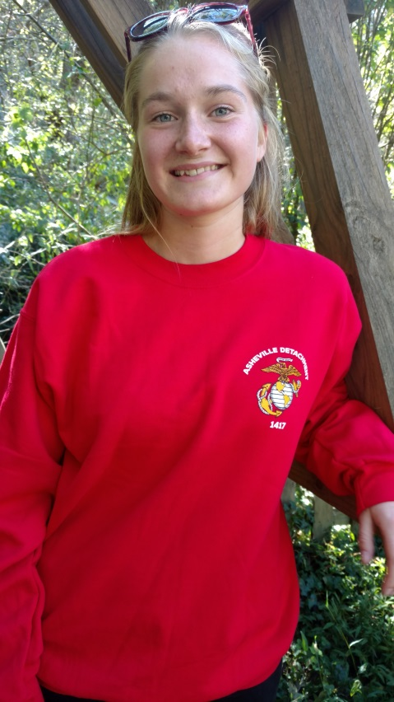

Remember to visit our Ship Store at our monthly meetings! Right now, we’re featuring our new sweatshirts for $25, and while supplies last, tshirts are on sale! Our red tshirts are on sale at $16 and the military green are on sale for $14! See Butch and Cecile to get yours today!
(Pictured is Signe Nystrup-Andersen who was visiting the Thornton-Laushance family on her visit to Asheville from Denmark in early October. She said “The sweatshirt is very soft and warm!”)

Our website address is:
www.ashevillemcl.org

≈≈≈≈≈≈≈≈≈≈
Are you on Facebook? Join us on our Facebook page at https://www.facebook.com/marinecorpsleagueasheville/

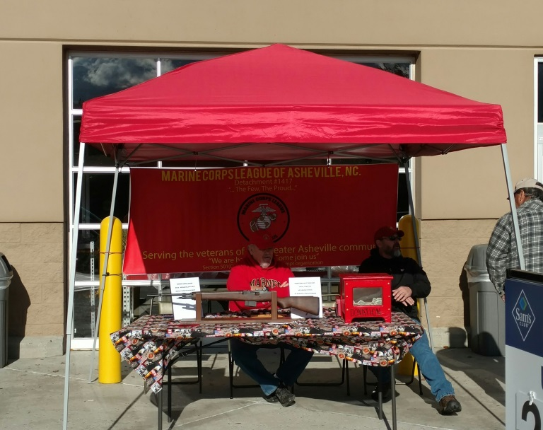
Pete Watts and Commandant Ric Ledford sitting outside the Sam’s Club selling Rifle Raffle Tickets on Saturday, October 22, 2016.

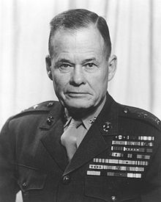
"Good night, Chesty, wherever you are!"

